
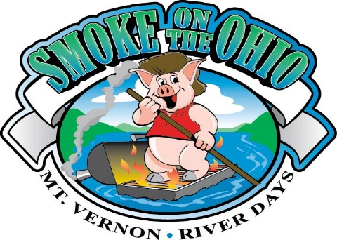

Smoke On The Ohio 28 Team Limit

Mt. Vernon, Indiana Riverfront September 12th & 13th, 2025

Team Name:_____________________________________________________________

Captain’s Name:___________________________________________________________

Captain’s Address: ________________________________________________________

City:______________________________State:__________________Zip:____________

Cell:_________________________Email:______________________________________

Site Information: Each team space will be approximately 20’ x 30’. No shelter will be available. All tents on site must use sand buckets to prevent stakes in direct contact with the street or landscaping. Water and one 20-amp electricity outlet will be provided. (Please bring extra-long water hoses and extension cords.) NO golf carts or 4 wheelers.
Send Entry now to hold your spot. Payment due by August 1st, 2025.
NO REFUNDS!

Your Equipment must fit in your Site Boundary KCBS #_____________

Entry Fee for 20’X30’ $225.00 _______

Entry Fee for 20’X40’ 20 Amp $250.00 _______

Entry Fee for 20’x40’ 7 spots-30 Amp $250.00 _______

Entry Fee for 20’x70’ 6 spots 30 Amp $275.00 ________

NOTICE: Early registrations in by June 1, 2025 can deduct $50 off your registration total.

Shirts: Each Smoke Master receives one free t-shirt: S M L XL 2X 3X 4X

Additional shirts: Size Number Cost
S ______x $15 = __________
M ______x $15 = __________
L ______x $15 = __________
XL ______x $15 = __________
2X ______x $15 = __________
3X ______x $15 = __________
4X ______x $15 = __________

TOTAL: ________________________

CASH _____ CHECK _____

Please make checks payable to & remit to:
Mt. Vernon River Days, P.O. Box 255, Mt. Vernon, IN 47620

WAIVER OF LIABILITY: I, the undersigned on behalf of myself and my team, intending to be legally bound, hereby, for myself, my heirs, my team, executors and administrators, waive and release any and all rights and claims for damages I or my team may have against Smoke On The Ohio, Mt. Vernon River Days, Inc., City of Mt. Vernon, Indiana, River Days Festival sponsors, representatives, employees, agents, volunteers, successors, and assigns for any and all injuries suffered by myself, my team, or my guests in the event. Further, I grant full permission to the event to use any photographs, video, or any other recording of the event for any legitimate purpose. I agree to abide by the rules and regulations of the event.

Signed________________________________________ Date______________

Any questions call Breckin Sauer @ (270) 577-7831
Email: smoke@mtvernonriverdays.com

