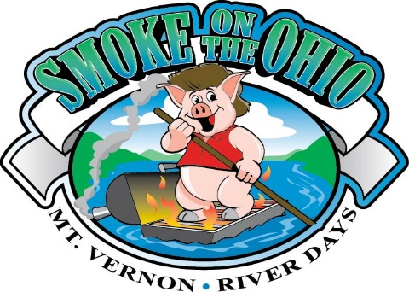

Mt. Vernon River Days
Sept. 12th and 13th
2025 Smoke on the Ohio BBQ Contest
Sponsorship Form

I ________________________________________________ (insert name) have made a commitment to sponsor the Smoke on the Ohio BBQ Contest. All sponsors will be listed on Banner.

- Company Sponsorship of Complete Event $ 3000 (16 Invitations to Sponsor Dinner)

- Master of the Awards Ceremony $ 3000 (16 Invitations to Sponsor Dinner)

- Platinum $ 1000 ( 8 Invitations to Sponsor Dinner)

- Gold $ 500 ( 6 Invitations to Sponsor Dinner)

- Silver $ 250 ( 4 Invitations to Sponsor Dinner)

Mt. Vernon River Days
Sept 12th and 13th
2025 Smoke on the Ohio BBQ Contest
Sponsorship Form

PAYMENT INSTRUCTIONS: Donations are payable to “Mt. Vernon River Days”. Attach this completed form and submit by August 1, 2025 to:

Mt. Vernon River Days
P.O. Box 255
Mount Vernon, IN 47620-0255

SPONSORSHIP INSTRUCTIONS: Print Sponsor name exactly as you would like it worded on Banner.
Sponsor Name:_____________________________________________________________________
Send Company Logo to smoke@mtvernonriverdays.com
Your Logo will be on Banner
Information: Call Breken Sauer (270) 577-7831 or email smoke@mtvernonriverdays.com
This is your receipt

***Mt. Vernon River Days, Inc. is a 501/C4 Corporation – 501c-4 #46-3527824***

