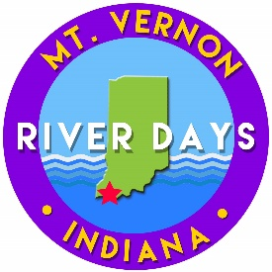

Mt. Vernon River Days Talent Show

Saturday, September 12th @ 11:00am

Amphitheater Stage

Parental Consent

Please read all the Talent Show rules and information. Complete the permission slip and attach it to one application for your group, along with one permission slip for every member in your group.

Please print.

Name (First and Last): Age:

Number of people in this act:

I give my child permission to participate in the Mt. Vernon River Days Talent Show. I have previewed this act to make sure it is within the talent show rules. We have read and agree to all the Talent Show Rules.

Parent/Guardian Name (please print):

Parent Signature:

Student Name:

Student Signature:

Forms must be turned in by August 16. We have room for 15 acts. If more
than 15 acts wish to participate, a decision will be made by the committee to decline selected performances or to expand the allotted time.

Questions: Contact Shelley Hargrove at shelleyhargrove2@gmai.com or 812-205-8675

